**ONLINE PERSONAL COUNSELLING FOR STUDENTS**

**IN PHINMA UNIVERSITY OF PANGASINAN**

A Capstone Project Presented to the Faculty of the

College of Information Technology and Education PHINMA - University of Pangasinan

In Fulfillment

of the Requirements for the Degree

BACHELOR OF SCIENCE IN INFORMATION TECHNOLOGY

By

ALJO D. SIOCO

DHIVEN PAUL D. SAPLAN

CRISTIAN AJ C. DELOS REYES

FRENCE E. VILLANUEVA

ALEX JOSHUA B. CALDERON

May 2022

**APPROVAL SHEET**

This project study entitled ONLINE PERSONAL COUNSELLING FOR STUDENTS IN PHINMA UNIVERSITY OF PANGASINAN prepared and submitted by FIRST NAME MIDDLE NAME FAMILY NAME in partial fulfillment of the requirements for the degree BACHELOR OF SCIENCE IN INFORMATION TECHNOLOGY, has been examined and is recommended for acceptance and approval for oral examination.

NAME OF ADVISER, Degree

Adviser

Project Study Committee

PANEL MEMBER (CAPS), Degree PANEL MEMBER (CAPS), Degree

Member Member

NAME OF CHAIRPERSON(CAPS), Degree

Chairperson

PANEL OF EXAMINERS

APPROVED by the Committee on Oral Examination on

__________________ with a grade of _________.

NAME OF CHAIRPERSON(CAPS), Degree

Chairperson

PANEL MEMBER (CAPS), Degree PANEL MEMBER (CAPS), Degree

Member Member

ACCEPTED AND APPROVED in partial fulfillment of the requirements for the degree BACHELOR OF SCIENCE IN INFORMATION TECHNOLOGY.

ARISTOTLE B. LIWANAG, MBA

Dean

College of Information

Technology Education

## ABSTRACT

Guidance and counselling is an important educational tool in shaping the orientation in a child from negative ideas that is planted in the child by his/her peers. Hence the need school for the counsellor to assist the child in molding their future through counselling therapy.

The goal is to explore their feelings, beliefs, and behaviors, work through challenging or influential memories, identify aspects of their lives that they would like to change, better understand themselves and others, set personal goals, and work toward desired change.

The participants for this study are the students of PHINMA University of Pangasinan (Dagupan Campus), particularly to those students who are in needs in guidance in their personal problems and mental health. The survey has been conducted through online form since it is the easiest, safest, and fastest way to collect data for our study because of COVID-19 Pandemic.

The result is process using System Usability Scale (SUS) and showed that that the implementation of PHINMA-UPang Online Student Counselling System will be beneficial to the students of PHINMA Upang (Dagupan Campus) in terms of their current situation. On this basis, the concept of this study will be taken into account by the researchers and will developed the proposed system.

The output will be as expected by the perception, insights, and feedbacks of the participants of this study.

**AKNOWLEDGEMENT**

The researcher would like to thank Ms. Veronica Canlas for her encouragement as the capstone adviser and who assisted the researchers in the overall manuscript. without them, the study would not been possible.

The researcher would also like to express gratitude to their parents and friends for providing them with the encouragement and support they needed to accomplish their capstone research in such a short period of time.

The researchers, ALJO D. SIOCO, DHIVEN PAUL D. SAPLAN, CRISTIAN AJ C. DELOS REYES, FRENCE E. VILLANUEVA, ALEX JOSHUA B. CALDERON, who participated and did not give up on making this project.

Lastly, to Almighty God who guided and gave them the strength to conduct this project.

## TABLE OF CONTENTS

ABSTRACT ii

TABLE OF CONTENTS iii

LIST OF TABLES v

LIST OF FIGURES vi

CHAPTER 1: PROJECT OVERVIEW 1

Background of the Study 1

Statement of the Problem 5

Objectives of the Study 6

Significance of the Study 6

Scope and Limitation 8

Definition of Terms 9

CHAPTER 2: REVIEW OF RELATED LITERATURES 11

Underrepresented Use of Online Grocery Shopping and the Sharing Economy 11

Consumers Preference on Grocery Shopping 12

Consumers Perception on Online Grocery Shopping 13

Consumers Online Grocery Buying Behavior 13

Grocery Delivery as The Ultimate Pandemic Lifeline 14

Synthesis of the Studied Literatures 14

CHAPTER 3: METHODOLOGY 16

Software Development Methodology 16

Data Gathering Tools 19

Sources of Data 20

System Design 22

SOFTWARE DESIGN AND ARCHITECTURE **25**

Software Architecture 25

Hardware and Software Requirement to Run the System 27

CHAPTER 4: RESULTS, DISCUSSIONS AND CONCLUSIONS 28

Problems and Issues Encountered, Manual/Current Procedures 28

Features of the Proposed System 35

Interpretation of Data (Software Usability Test) 67

Conclusion 69

Recommendation 70

REFERENCES 71

Survey Questionnaire – Survey on ShopGO Supermarket Delivery System 74

CURRICULUM VITAE 77

|  |  |  |
| --- | --- | --- |
|  | **LIST OF TABLES** |  |
| **Table No.** | **Title** | **Page** |
| 1 | Participants of the Study | 21 |
| 2 | Hardware Requirements | 27 |
| 3 | Software Requirements | 27 |
| 4 | Likert-type Scale for Level of Usability | 28 |
| 5 | Individual SUS Score | 67 |

## LIST OF FIGURES

**Figure No. Title Page**

|  |  |
| --- | --- |
| 1 Agile Development Methodology | 17 |
| 2 Participants by Age | 21 |
| 3 Use Case Diagram | 24 |
| 4 Layered Software Architecture | 26 |
| 5 Level of Usability for Frequently Use | 29 |
| 6 Level of Usability for Complexity | 39 |
| 7 Level of Usability for Ease of Use | 30 |
| 8 Level of Usability for Technical Support | 30 |
| 9 Level of Usability for Well-Integrated Features and Functions | 31 |
| 10 Level of Usability for Inconsistency | 31 |
| 11 Level of Usability for Ease of Learning | 32 |
| 12 Level of Usability for Inconveniency | 33 |
| 13 Level of Usability for Confidence | 33 |
| 14 Level of Usability for Learnability | 34 |
| 15 Admin: Login Module | 35 |
| 16 Admin: Dashboard Module | 36 |
| 17 Admin: Stores Module | 37 |
| 18 Admin: Product Categories Module | 38 |
| 19 Admin: Products Module | 39 |
| 20 Admin: Orders Module | 40 |
| 21 Admin: Company Reports Module | 41 |

1. Admin: Couriers Module 42
2. Admin: Courier Reports Module 43
3. Admin: Customer Module 44
4. Admin: Customer Report Module 45
5. Courier: Login Module 46
6. Courier: Upcoming Orders Module 47
7. Courier: Order History Module 48
8. Courier: Order Details Module 49
9. Courier: Order Reports Module 50
10. Courier: Order Report Details Module 51
11. Customer: Sign Up Module 52
12. Customer: Login Module 53
13. Customer: Forgot Password Module 54
14. Customer: Store Module 55
15. Customer: Dashboard Module 56
16. Customer: Products Module 57
17. Customer: Product Details Module 58
18. Customer: Cart Module 59
19. Customer: Place Order Module 60
20. Customer: Orders Module 61
21. Customer: Order Details Module 62
22. Customer: Order Reports Module 63
23. Customer: Order Report Details Module 64
24. Customer: Profile Module 65
25. Customer: Manage Profile Module 66
26. SUS Score of ShopGO Supermarket Delivery System 68

## Chapter 1 PROJECT OVERVIEW

## Background of the Study

Guidance and counselling is an important educational tool in shaping the orientation in a child from negative ideas that is planted in the child by his/her peers. Hence the need school for the counsellor to assist the child in molding their future through counselling therapy.

According to Arnout et al., 2020; Liebrenz et al., 2020, at the time of the COVID-19 pandemic outbreak, human activities were no longer the same as before. Various countries in the world imposed regulations for working from home, studying from home, social distancing, physical distancing, etc. Furthermore, these adjustments may eventually have triggered mental health symptoms, such as anxiety, depression, stress, and so on.

Online counselling become helpful to us during this time of pandemic, because we know that some of us suffer from mental health issues such as anxiety, stress, and depression. Mental health has a big impact on our daily lives but because of this pandemic many of us experienced mental health problems during lockdown but because of online counselling it become helpful in many situations it gives personal counselling that helps them understand themselves and learn more about health behaviors that will lead them to better health.

Most people, at some point in their lives, face adjustment difficulties or other mental health challenges. Studies in Malaysia have estimated that between 9.6 and 35% of the population; around 2.8–10 million individuals, could benefit from, but are not receiving, mental health support (Crabtree and Chong, 2000; Chong et al., 2013).

As technology advances, internet services become an increasingly important aspect of our life. It is possible to state that many people have access to education, business, and even relationships. It is inconceivable to imagine the elderly or the young not having access to information and communication via the internet on their phones, tablets, or computers in seconds. Counseling is one of the fields that is affected by computer technology in such an atmosphere. Although it appears to be a new concept, online counseling is one of the psychological services based on information technology and the internet that is widening the reach of counselors by using various online support kinds and integrating vital services for aid and support.

Online counseling is defined as providing counseling services over the internet where the counselor and client are not physically present and communicate via computer-based technologies. Cyber psychology, e-therapy, e-counseling, or cyber-therapy are terms used to describe providing therapeutic interventions over the internet. Furthermore, in the literature, online counseling is referred to by several words such as web counseling, web-based psychotherapy, tele-counseling, distance counseling, and avatar-based counseling. Asynchronous e-mail, synchronized e-mail, instant messaging, textual messaging, and video conference are all examples of online counseling applications.

There are numerous studies that show the usefulness of internet counseling. When compared to telephone support, chat support is deemed to be more qualitative and to have equivalent good impacts. Chat support is thought to be the most useful since it is similar to offline therapy. Specifically, chat talks (for example, offline counseling sessions) that reveal vital personal information and are relieving are thought to be more beneficial.

A number of researches have been carried out to assess the efficacy of online assistance. Chat and e-mail assistance have been reported to be useful in the treatment of loneliness, depression, panic disorder, insomnia, and cigarette cessation. did a meta-analysis of 12 trials studying telephone-based depression therapy and discovered that symptoms dropped significantly when compared to face-to-face counseling, and that telephone support assisted cigarette smokers in quitting. indicated that text-based advice helped to lower depression rates; discovered that beneficial benefits from online depression therapy took longer than face-to-face counseling. Despite their reservations, counselors have a good attitude toward online counseling and believe that it should be used, according to the findings of research that investigate the perspectives of counselors and counseling trainees on the subject.

The findings of their research on the perspectives of parents, students, and counselors on conducting counseling and guidance at high schools over the internet. While parents and students had positive feelings about it, counselors had negative feelings about it. The findings of the study, which looked at the perspectives of counseling trainees who give online counseling on therapeutic cooperation, revealed that online counseling may be utilized as a substitute for traditional face-to-face therapy.

In their study of counselors' attitudes regarding online counseling, they looked at it from the standpoint of the counselors. Counselors have neither a positive nor a negative attitude regarding online counseling, according to the study. In terms of client satisfaction with online counseling, the findings revealed that clients are satisfied with the procedure. According to the findings of the studies, additional study should be conducted on this topic in order for online counseling to be incorporated in training programs, developed, and implemented widely. More research and advancement in this subject is urgently needed, according to the report. As a result, the study's goal is to look at the perspectives of trainee counselors on the usage of online counseling in psychological services. This research is expected to benefit online counseling practice and implementation.

This web application is an Online Personal Counselling for Students in PHINMA University of Pangasinan and we will name the website “Making Lives Better”. It focuses on students that needs personal counselling especially now that we are still in the situation of pandemic, gives students necessary support such as helping them to understand themselves and their needs, to solve their problems, to make realistic decisions, to improve their abilities and skills, and to adjust themselves and their environment in a healthy way.

The goal is to explore their feelings, beliefs, and behaviors, work through challenging or influential memories, identify aspects of their lives that they would like to change, better understand themselves and others, set personal goals, and work toward desired change.

## Statement of the Problem

This project aims to design and develop an Online Student counselling System for PHINMA University of Pangasinan that will help the students to refresh their minds, release their hidden emotions, and to relieved the stressful environment. By this, the students will regain the strength to face the reality, to overcome fear and to boost self-confidence. Most of the students have same difficulties in life in experiencing this pandemic that leads into lack of concentration in their study and it looks pitiful that slowly going down, so it came into an idea to help them by conducting online personal counselling:

* 1. The students facing a heavy work pressure.
  2. Lack of parental support and support from school administration.
  3. Low self-confidence and self-esteem.
  4. Problems of adjustment and other problem of life educational and vocational problems.
  5. Interpersonal and relationship difficulties.

Having that as a basis, the proponents of this project came up with building a website for student of PHINMA University of Pangasinan that will help student to shape their behavior and instill enough discipline in them.

## Objectives of the Study

The main objectives of this project is to assist and develop them by:

1. To ease the mind of the study by having someone to talk to.
2. To seek support from our very own school administration.
3. To boost the confidence and self-esteem of our students.
4. Learn to embrace changes.
5. To enlighten the student that he/she is not alone.

## Significance of the Study

This study will be beneficial to the following: students, parents, and the school. The project’s goal is designed to help people mostly:

Students – For students, this is a good start for them to grow, to make things right, to make them feel better, to boost their confidence, to understand their point of view better, and to make their path right. In this, students can now explore and adjust their hidden talents, feelings, and behaviors.

Parents – The Online Personal Counselling would be a great help to the parents in correcting their child’s path, and behaviors. This will also help the parents feel better by knowing their children and without their presence are going to the right path, right guidance and right counselling from the school.

School – Online Personal Counselling would be a great step of the school by conducting counselling and guidance to the students. This is a pride for the school that their students are being proud of and being a product for their good guidance. Moreover, the guidance they made, the student would never forget.

To the researcher – The skills of the researcher in this study shall be further improved because the knowledge and experience obtained during the development of the study.

To the future researchers – This study shall serve as an essential reference for future studies in line with the Guidance and Counselling.

To the Developers – This shall improve the productivity of the developers. The proposed application will also benefit the developers to learn more on creating an application. Since everyone can accessed easily. This reduces the workload of the entire developers.

To the Future Developers – This shall serve as an essential reference for creating future application. In this, the future developers will have background on how to execute properly and to develop more.

To the Researchers – The skills of the researcher in this study shall be further improved because the knowledge and experience obtained during the development of the study.

To the Future Researchers – This study shall serve as an essential reference for future studies in line with the Guidance and Counselling.

## Scope and Limitation

## Scope

In our Project Scope we want to share the features of the title that we have for all of the students that will able to use this website as an extra information.

1. Positivity - This is the main goal that we want for all of the students in PHINMA even if we're in a rough times we can always do a solution to do our jobs.
2. Motivation - We do give students some advice for their studies and motivate them to be a better student.
3. Monitoring their Situations - Knowing a students situations could help us to advise them.
4. Mentoring - we give directions to the students in to the right path.

**Delimitations**

Delimitations are the few things that we can only do for counselling students and the limitations of our website.

1. In this website we only have our thoughts to share for us to advise students.
2. Only PHINMA University of Pangasinan Students are able to use this website by using their ID number.
3. This web app doesn't have a mobile app.

## Definition of Terms

The key terms in the study are given the following conceptual definitions:

Adherence – the quality or process of sticking fast to an object or surface.

Anxiety – a feeling of worry, nervousness, or unease, typically about an imminent event or something with an uncertain outcome.

Counselling – give professional help and advice to (someone) to resolve personal or psychological problems.

Cyber-Therapy - Some researchers and clinicians define cyber-therapy or "e-therapy" as clinical work via e-mail or chat - work that is text-based, usually ongoing, and mostly or exclusively conducted through the Internet.

Counselors - a person trained to give guidance on personal, social, or psychological problems.

Depression – feelings of severe despondency and dejection.

Efficacy – the ability to produce a desired or intended result.

E-Counselling – Online therapy, also known as e-therapy, e-counseling, teletherapy, or cyber-counseling, involves providing mental health services and support over the internet. Services can be offered through email, text messaging, video conferencing, online chat, messaging, or internet phone.

E-Therapy – E-therapy is a term that has been coined to describe the process of interacting with a therapist online in ongoing conversations over time when the client and counselor are in separate or remote locations and utilize electronic means to communicate with each other.

Inconceivable - not capable of being imagined or grasped mentally; unbelievable.

Meta-analysis – examination of data from a number of independent studies of the same subject, in order to determine overall trends.

Pandemic – (of a disease) prevalent over a whole country or the world.

Psychology – the scientific study of the human mind and its functions, especially those affecting behavior in a given context.

Superordinate – noun -a thing that represents a superior order or category within a system of classification.

Therapeutic – adjective - relating to the healing of disease.

## Chapter 2

**REVIEW OF RELATED LITERATURES**

This chapter presents a review of literature and studies identified with students that needs online counselling in their personal problems/issues. This also synthesizes the gap of study bridged, theoretical framework terms are defined conceptually and operationally for clarity.

**Therapists' experiences of providing online counselling: A qualitative study**

According to Jonell Smith Ewan Gillon of School of Health and Life Sciences, Glasgow Caledonian University, Glasgow, UK (04 May 2021), technology-delivered psychological interventions, particularly online and telephonic counselling, have flourished in recent years, with the need for such a flexible delivery method increasing due to the COVID-19 pandemic. While empirical research on technology-delivered psychological interventions is limited, findings indicate that therapists have a positive attitude towards online counselling. There is a particular lack of research on therapists' perceptions and experiences of using technology-delivered interventions. The primary aim of this study was to explore therapists' experiences of providing online counselling, thereby gaining insight into the therapeutic experience, processes and efficacy from the therapists' perspective. Data were collected through semi-structured interviews with five therapists, registered with organizations providing professional counselling and psychotherapy, with experience of providing synchronous/real-time online video, audio or chat-mediated counselling sessions. The interviews comprised open-ended questions. Interpretative phenomenological analysis was used to analyze the data, through which two superordinate themes were identified: (a) environmental adaptation and (b) practice enhancement. Our findings suggest that therapists’ online counselling experiences incorporate several factors related to environmental adaptation and practice enhancement that impact the therapeutic process, outcomes, progress and relationship. The findings could inform the development of training, awareness-raising and skills-enhanced interventions for psychotherapists already using and hoping to use online therapeutic interventions.

**A randomized controlled trial on a self-guided Internet-based intervention for gambling problems**

According to Lara Bücker, Josefine Gehlenborg, Steffen Moritz & Stefan Westermann (2021), internet-based interventions for psychological disorders (e.g., depression, anxiety) represent a promising alternative to conventional face-to-face treatment as they are able to address specific treatment barriers and maintain effectiveness. These interventions can reach individuals who avoid personal contact (e.g., due to feelings of shame or concerns about anonymity), live in rural areas, or have problems with mobility. In addition, they are easily accessible and are available at lower costs compared to conventional treatment. Internet-based interventions are either guided (with personal therapeutic support via e-mails, telephone calls, messages), self-guided (without personal therapeutic support), or blended (combination of an Internet-based intervention and classical face-to-face treatment). Such interventions have been intensively researched in recent years for a number of psychological disorders with regard to efficacy, acceptance, adherence, and side effects. In this context, guided interventions have proven to be the most effective in terms of symptom reduction, with medium to large effect sizes in, for example, affective disorders. Although smaller effects are found with self-guided interventions, some specific advantages apply as they do not require many resources (e.g., no therapists are needed), are less costly, can be started without a waiting period, and can be used in a completely flexible manner depending on the individual's needs.

**Preferences for Online and/or Face-to-Face Counseling among University Students in Malaysia**

According to Kah P. Wong, Gregory Bonn, Cai L. Tam, and Chee P. Wong (2018),Increasingly, online counseling is considered to be a cost-effective and highly accessible method of providing basic counseling and mental health services. To examine the potential of online delivery as a way of increasing overall usage of services, this study looked at students’ attitudes toward and likelihood of using both online and/or face-to-face counseling. A survey was conducted with 409 students from six universities in Malaysia participating. Approximately 35% of participants reported that they would be likely to utilize online counseling services but would be unlikely to participate in face-to-face counseling. Based on these results, it is suggested that offering online counseling, in addition to face-to-face services, could be an effective way for many university counseling centers to increase the utilization of their services and thus better serve their communities.

## Chapter 3 METHODOLOGY

In this chapter, the researchers will discuss the problems encountered in the existing system, the features of the proposed system, the interpretation of data and the different types of system design.

## Software Development Methodology

Software development methodology refers to structured processes involved when working on a project. It is a blend of design philosophies and pragmatic realism that stretches back to the early days of computing. The goal is to provide a systematic approach to software development.

Throughout the years, various software development methodologies were introduced to capitalize on the available technologies and resources. Software development methodology provides a platform for developers to work together more efficiently as a team. It formalizes communication and determines how information is shared within the team.

By doing the researchers projects, all researchers need a software which will help them for their projects. A stable software development methodology is what they need for a much better project.

The researcher used Featured Driven Development (FDD) which is perceived to be the best in constructing a systematic plan for the development of the proposed system.

An Agile methodology for developing software, Feature-Driven Development (FDD) is customer-centric, iterative, and incremental, with the goal of delivering tangible software results often and efficiently. FDD allows teams to update the project regularly and identify errors quickly. Plus, clients can be provided with information and substantial results at any time. FDD is a favorite method among development teams because it helps reduce two known morale-killers in the development world.

FDD consists of five clearly defined processes. The processes that make up FDD are structured around defining every element of a project as a feature, then designing and building each feature in an iterative manner. The figure below illustrates the flow of the FDD process.

Figure 1.

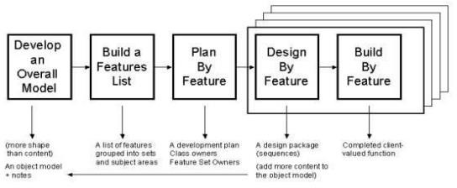

Develop an Overall Model. Researchers present an initial high-level, highlights-only walkthrough of the scope of the system and its context. The domain and development members produce a skeletal model, the very beginnings of that which is to follow. Then the domain members present more detailed walkthroughs. Each time, the domain and development members work in small sub-teams, present sub-team results, and merge the results into a common model, adjusting model shape along the way.

The activity used in Software Development Methodology is conducting a survey. the reason is we are in the middle of pandemic and for the safety of everyone it conducts via google forms. Researchers can count all the votes online so that they can gather data from the survey. If there are some problems like bugs or viruses the researchers can fix the problems ASAP. Furthermore, the researchers gather data in real-time communication with the respondents if there's any doubt about this project.

Build a Features List. In this phase, the team should have basic understanding of the presented project. Team should use the overall model to identify which features will be required. Remember that in FDD, ‘features’ are similar to user stories — so think about the development activities which will need to happen to bring your product or software to life. The team should have basic understanding of the presented project.

Plan by Feature. Next step is plan by feature. In this phase implementation order of feature is decided, the team should allocate reasonable estimates to each feature, assign them to a team member and work out what needs to happen for these deadlines to be met. For ultimate success, all team members should take part in this process.

Design by Feature. The team create different designs with their features. Teams should design concurrently and collaboratively. In this phase, the team should collaborate to create the design and its different kinds of features. The team will make sure that the design will be uniform and will avoid different kinds of chaotic layout and it will be appropriate to all.

Build by Feature. This is the most important phase in the FDD methodology and it is allotted the longest amount of time to complete the proposed system.

The team should work on their individual build responsibilities at the same time — visual designers on the UI, programmers on coded components, etc. When everything is ready to be pulled together, it’s sent to QA for testing. Then, the next feature can be tackled.

## Data Gathering Tools

The researcher used the instruments and techniques that is necessary to complete the development of Online Personal Counselling for Students of PHINMA University of Pangasinan which includes observation, personal interview with the target respondents, document analysis, and construction of evaluation forms for determining the study’s worth and significance.

The data was collected at a time that was most convenient for the respondents and the researcher for interaction, resulting in a higher level of information acquisition that was important in achieving the study's objectives.

Observation. This is a direct means of getting information on how the current system works. The researcher observed the respondent via video chatting to evaluate their behavior towards Online Personal Guidance and Counselling.

Interview. The researcher conducting interviews through social media flatforms to understand their insights of Online Personal Counselling and to gather more information and to identify the problems that may occur. This interview was made to effectively collect data from the respondents.

Document Analysis. The researcher conducts analyzing, interpreting and collecting data from the google to support the researcher to adopt the same document that will used in the proposed Online Personal Counselling.

Survey Questionnaire. The researcher conducts survey questionnaire via google forms to help the researchers gather the needed data from the respondents.

Researchers used a Data Gathering Technique which is Survey. We gather data in every person that will answer the questions. The main Source of Data that we have is the opinion of the respondents. Researchers also observe the process online and identity the problem in the system.

The researchers gather data to those UPANG students that needed guidance and counselling during this time of pandemic, and to those who are willing to experience counselling through online. We gather data in every person who answered in google forms. The main source of data that we have is the opinion of the respondents.

## Sources of Data

This section presents the entities, people, materials used as primary and secondary sources for the data that is vital for our research study and the proposed system. Also, the tabular presentation of the chosen participants.

Primary sources were collected through questionnaires and surveys. Due to the pandemic since this is the safest, fastest, and easiest technique that the researchers can think of to collect data of the chosen respondents. The online surveys have been distributed only to those students who experiencing problems or issues in their personal lives, especially those who has no one to talk with their problems.

Secondary sources are information that were collected from the internet such as previous thesis documents, online articles, and pre-existing systems that are related to the proposed system.

The participants of this study are the people who are regular shoppers that are fond of grocery shopping in traditional and online customers, since these people have the knowledge and experience in terms of buying or ordering groceries. Couriers, who had experience working on other delivery services, since they are the ones who delivers the orders of the customers.

Table 1:

Participants of the Study

|  |  |
| --- | --- |
| **Type of User** | **Total of Respondents** |
| Students of Upang(Dagupan Campus | 100 |

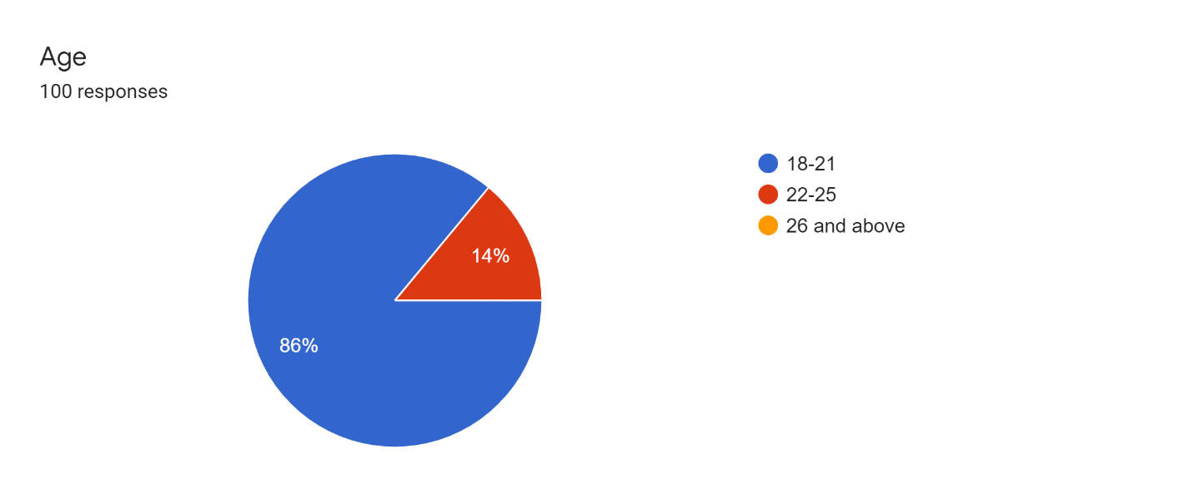Figure 2: Participants by Age

Figure 2 shows that the majority of participants are aged at 18-21 years old which numbers to 86%. The rest are 14% aged 22-25 years old. There are no participants aged 26 and above.

## System Design

In this section, the Use Case Diagram will be presented and describe the interaction between the users or entities with the system. The purpose of this diagram is used to gather the requirements of a system together with internal and external influences. These requirements are mostly design requirements. Hence, once the system is analyzed to gather its functionalities, use cases are ready and actors are identified.

Admin is the person that can only access and manage the registered students in PHINMA University of Pangasinan, he/she can delete user’s accounts. Also, the admin can edit students and counsellor. And the admin will be the one will add new students.

Students can access the app by using the student number provided by the school and the password would be the last name of the student, the student can book his/her appointment for the counselling and he/she waits for the approval of the counsellor. Once it is approved the counsellor would send a link of the virtual counselling. Then the student and counsellor can now start. After the counselling, the result is needed if the student needs a follow-up meeting. And the student and counsellor are done the students can now logout the application.

Counsellor/Professor are the one who will give a counselling to the students that have issues in his/her life. Once the counsellor approved the appointment made by the students the counsellor needs to send a link for their virtual meeting. The student and counsellor can now start the virtual meeting. After the meeting, the counsellor will evaluate the student if he/she needs a follow-up meeting. Then the professor can also logout the application.

Figure 3:

Use Case Diagram

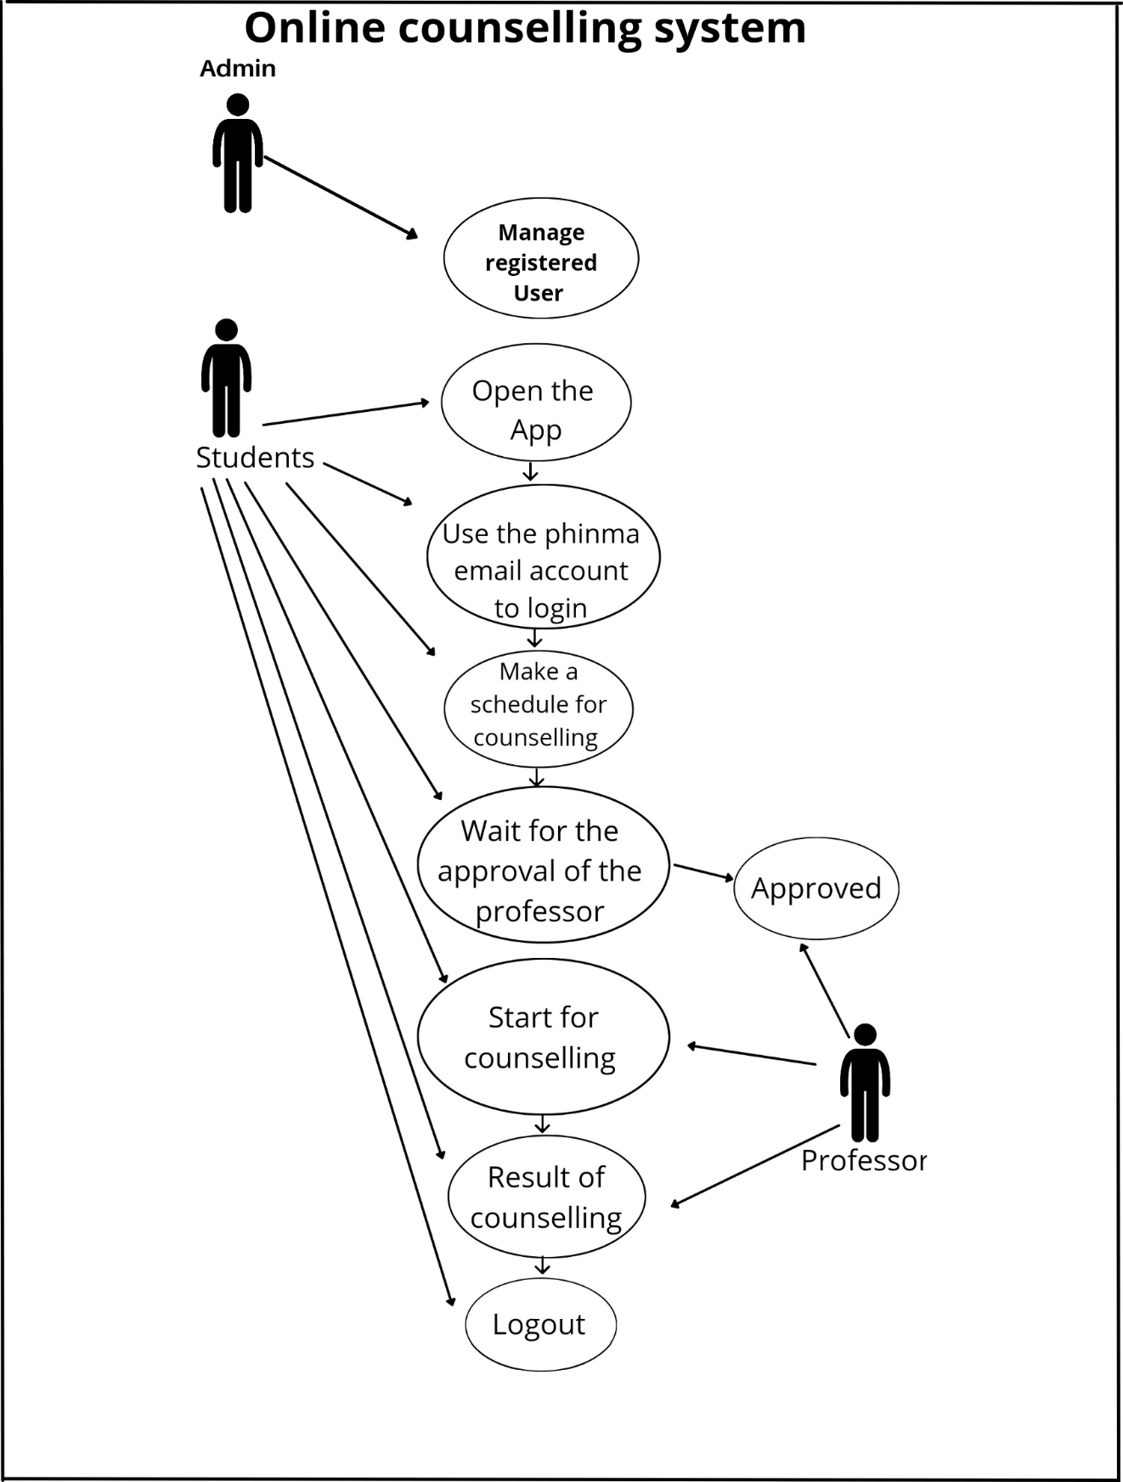

## SOFTWARE DESIGN AND ARCHITECTURE

In this section, the Software Architecture, Software Design, and the Hardware and Software System Requirement will be discussed in order to thoroughly understand the properties of the proposed system.

## Software Architecture

The researchers have a set of patterns and techniques to follow upon the development process of the mobile application, a Layered Software Architecture will be used. This software architecture is chosen because naturally, most applications work in layers and these layers allow better system customization which is very ideal on the project.

Moreover, whenever changes on each component of a layer occur, it won’t affect the other layers because they can be independent from one another. This will be consequential to the developers as the system has each specific layer that contains different components. It makes writing a systematic and testable application way easy.

Figure 4:

Layered Software Architecture

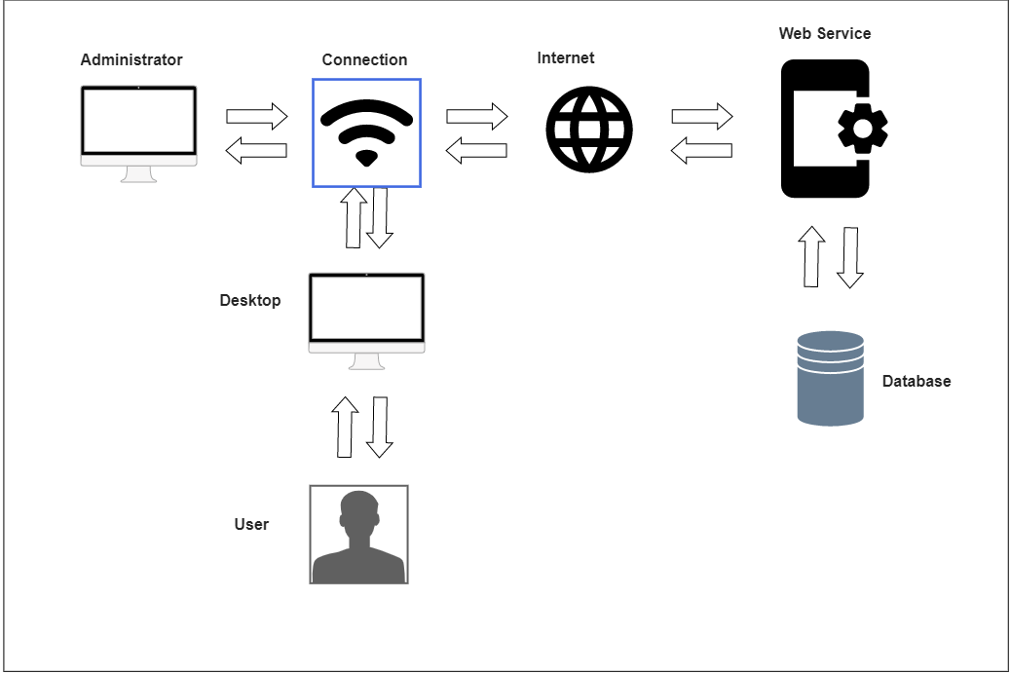

The software architecture that is shown above illustrates the client-server. It depicts user-website interaction. All data will be kept in the database once the user begins using the website over the internet, which will subsequently be navigated by the administrator and seen by authorized workers.

Administrator - The one who owns the website and the one who’s responsible for running the website.

Connection – This served as a link between the administrator and the internet.

Web Service – is an application or data source that is accessible via a standard web protocol (HTTPS)

Desktop – it used by the user to access the website.

Database – Serves as database, it stores all of the records.

User – The one who is using the website

Figure 5:

Logical Design

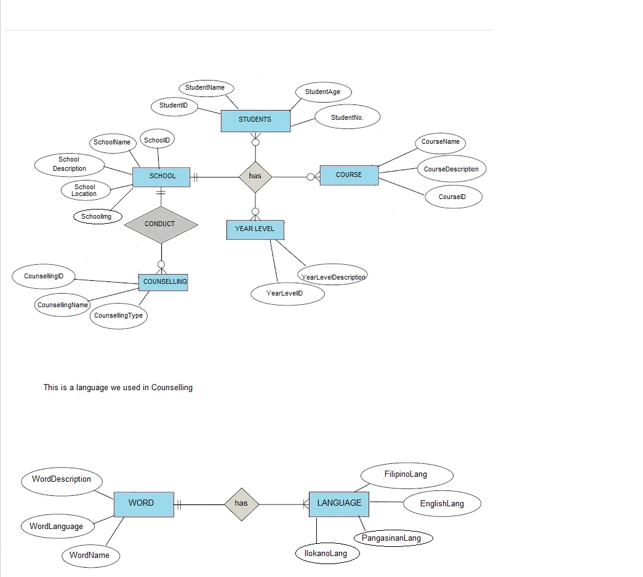

The logical design illustrates the implementation details.

## Hardware and Software Requirement to Run the System

This section shows the hardware and software requirements in order to properly run the system both in android and web application.

Table 2:

Hardware Requirements

|  |  |  |
| --- | --- | --- |
|  | **Minimum** | **Recommended** |
| Web Display | 1440 x 900, 16 bits | 1920 x 1080, 32 bits |
| PC RAM | 1 GB | 2 GB |
| PC Processor | Pentium 500 MHz | Pentium 500 MHz – Intel Core i7 Processors |
| PC Hard Disk Space | Up to 500 MB | 500 MB – 1 TB |
| Internet connection | Usually necessary | Usually necessary |

Table 3:

Software Requirements

|  |  |
| --- | --- |
|  | Required Software |
| Browser | Microsoft Edge and Google Chrome |
| Desktop Operating System | Macintosh, Windows 7, Windows 8.1, and Windows 10. Both 32- and 64-bit versions of Windows and Macintosh can be used.  Microsoft .NET 4 framework |
| Host Application | XAMPP Control Panel and Firebase Hosting. |

## Chapter 4

**RESULTS, DISCUSSIONS AND CONCLUSIONS**

This chapter presents the results of the collected data from the survey, interpretation of data findings, discussion about the features of the proposed system, and conclusion and recommendations of the study.

## Problems and Issues Encountered, Manual/Current Procedures

In this section, the researchers present the results of the collected data from the provided questionnaire, surveyed by the chosen participants who are in needs of online counselling in their personal problems/issues. The researchers also present the visual presentation of the findings from the conducted survey. Each of these visual presentations is accompanied by a five-point Likert-type scale to analyze the perceptions, insights and feedbacks of the chosen participants about the proposed system to measure the level of usability.

Table 4:

Likert-type Scale for Level of Usability

|  |  |
| --- | --- |
| **Scale Range** | **Remark** |
| 1 | Strongly Disagree |
| 2 | Disagree |
| 3 | Neutral |
| 4 | Agree |
| 5 | Strongly Agree |

Figure 6:

Level of Usability for Frequently Use

Figure 5 shows the results that out of 100 responses, 47% of the participants strongly agreed that they believe online mental health counselling or therapy can be as effective as in-person treatments, while 38% of them agreed.

Figure 6:

Level of Usability for Complexity

Figure 6 shows the result that out of 100 responses, 31% strongly agreed that online health counselling with a therapist that they have not met in person can offer effective therapy, while 2% don’t think that online health counselling with a therapist that they have not met in person can offer effective therapy.

Figure 7:

Level of Usability for Complexity

Figure 7 shows the result that out of 100 responses, 32% of the participants strongly agreed that it is easy to say or discuss your emotional problems with an online counsellor, while the other 38% of them agreed.

Figure 8:

Level of Usability for Complexity

Figure 8 shows the result that out of 100 responses, 27% of the participants strongly agreed that online health counselling helps you to be the best version of yourself, while 46% agreed.

Figure 9:

Level of Usability for Complexity

Figure 9 shows the result that out of 100 responses, 37% of the participants strongly agreed online counselling can help the students lean more about themselves, while 48% of them agreed, and 16% of them remains neutral, disagree and strongly disagree.

Figure 10:

Level of Usability for Inconsistency

Figure 10 shows the result that out of 100 responses, 40% of the participants strongly agreed online counselling can help the students lean more about themselves, while 48% of them agreed, and 12% of them remains neutral, disagree and strongly disagreed.

Figure 11:

Level of Usability for Ease of Learning

Figure 11 shows the result that out of 100 responses, 30% of the participants strongly agreed that they would use online counselling if they needed mental health services, while the other 48% of them agreed.

Figure 12:

Level of Usability for Inconveniency

Figure 12 show the result that out aof 100 responses, 41% of the participants strongly agreed that seeking help with a online counselor will help student to maintain their mental health, while 2% of them disagreed.

## Features of the Proposed System

This section presents the individual modules of the developed system. Each module will be discussed in order to fully understand their functionalities and capabilities in the system.

Module 1. The Home Page. This is the introductory of our website. The page where you can find all of the important details that will help the users to use the website properly it includes a navigation bar that provides links to different sections within the website .

Figure 13:

Home page

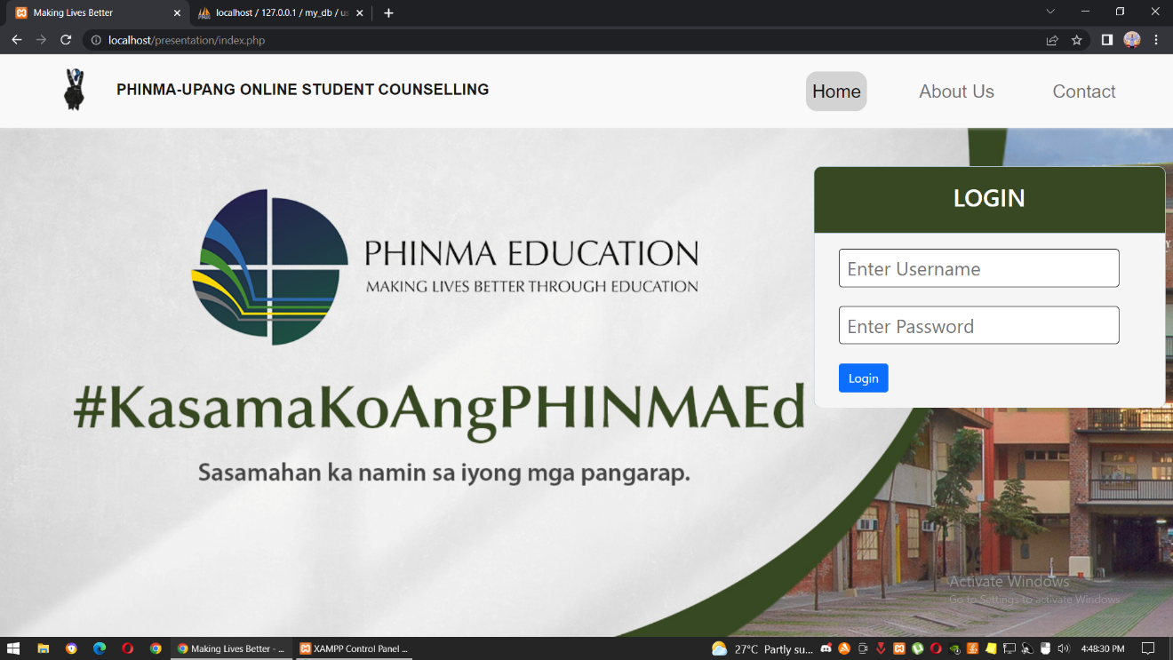

Module 2. About Us Page. The page that shows information about our website. To inform the users about our system and share the purpose of our system.

About Us Page

Figure 14:

About Us Page

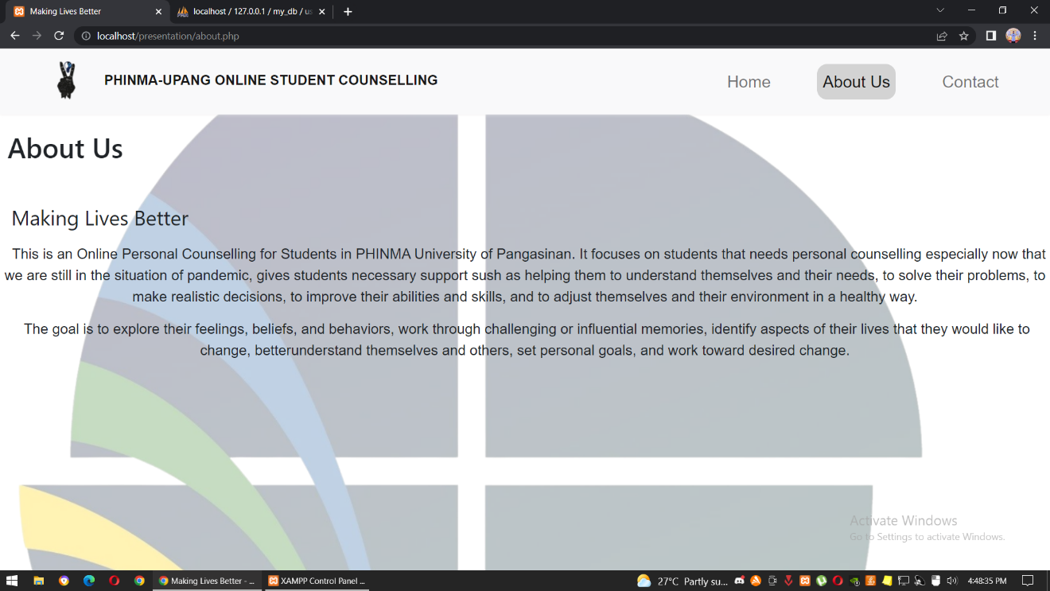

Module 3. Contact page the page where the users can send feedbacks, questions, concerns or recommendations about our website and it also provides them with the information on how they can get in touch with you.

Figure 15

Contact Us Page

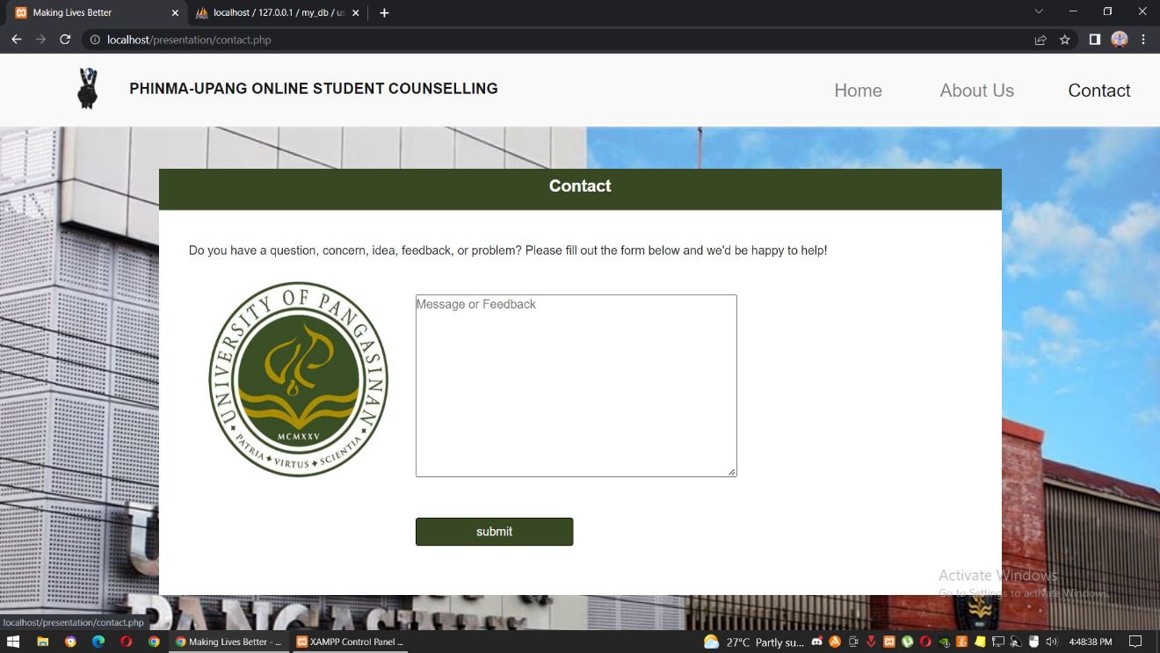

Module 4. Book Appointment - The page where you will need to book an appointment in order to make your counselling approve. The page is consist of form that requires you to answer in order to book an appointment. The student will input their full name, the date and time of their appointment and their key issue/s.

Figure 16

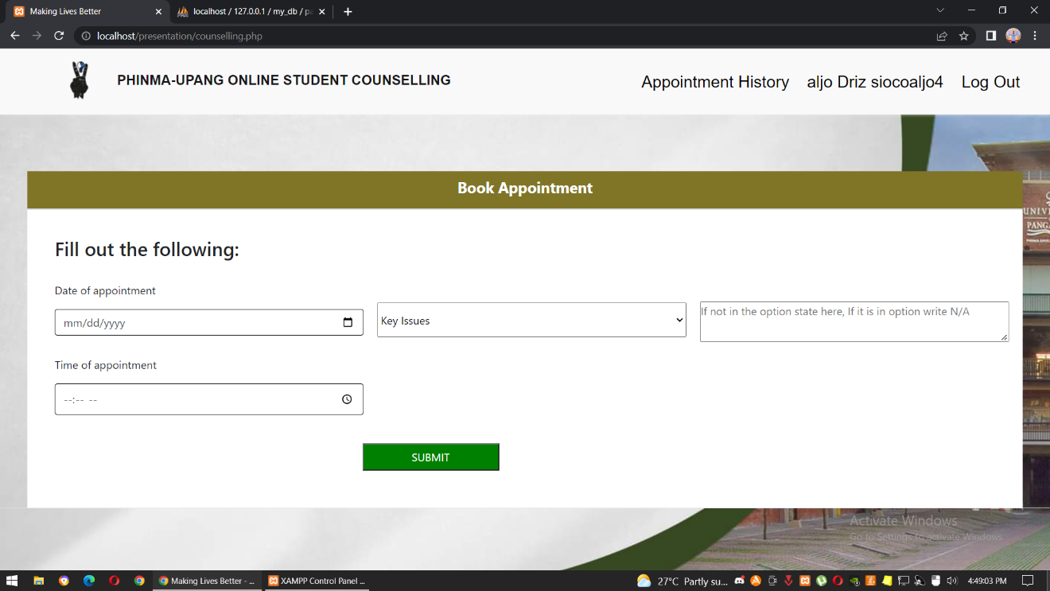 Counselling Page

Module 5. Admin Login - Page where the admin can open their accounts. In the admin page, they can add, edit or delete an student or counsellor account. The admin will have the control on the system.

Figure 17

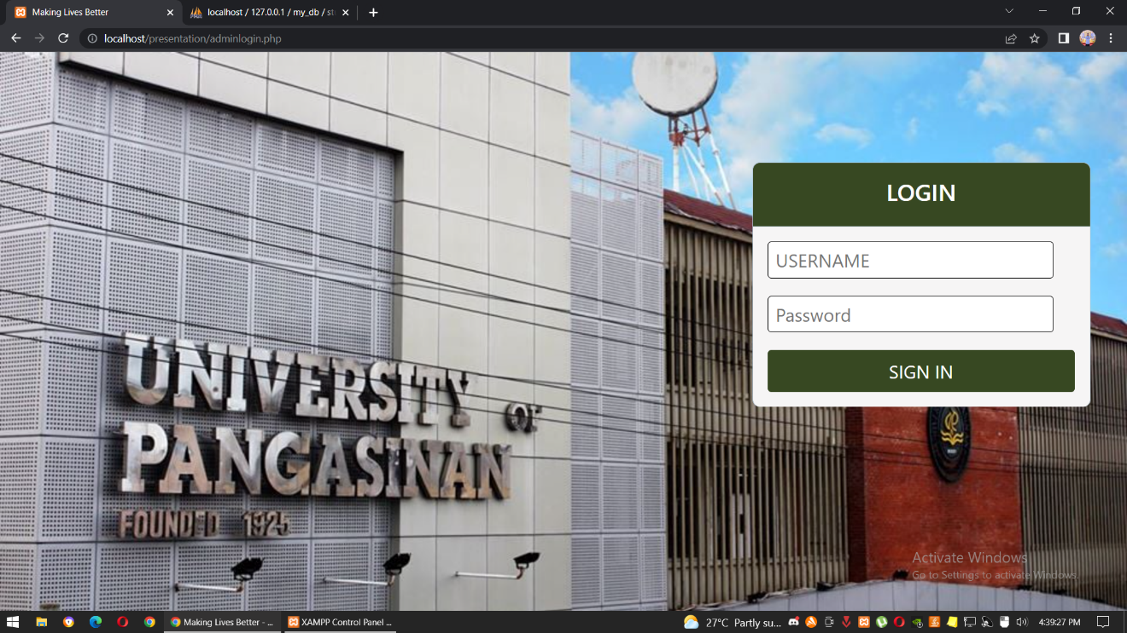Admin Login

Module 6. View Student - The page where the information of the students can be edited. In this page, you can delete or edit the information of the student.

Figure 18:

View Student

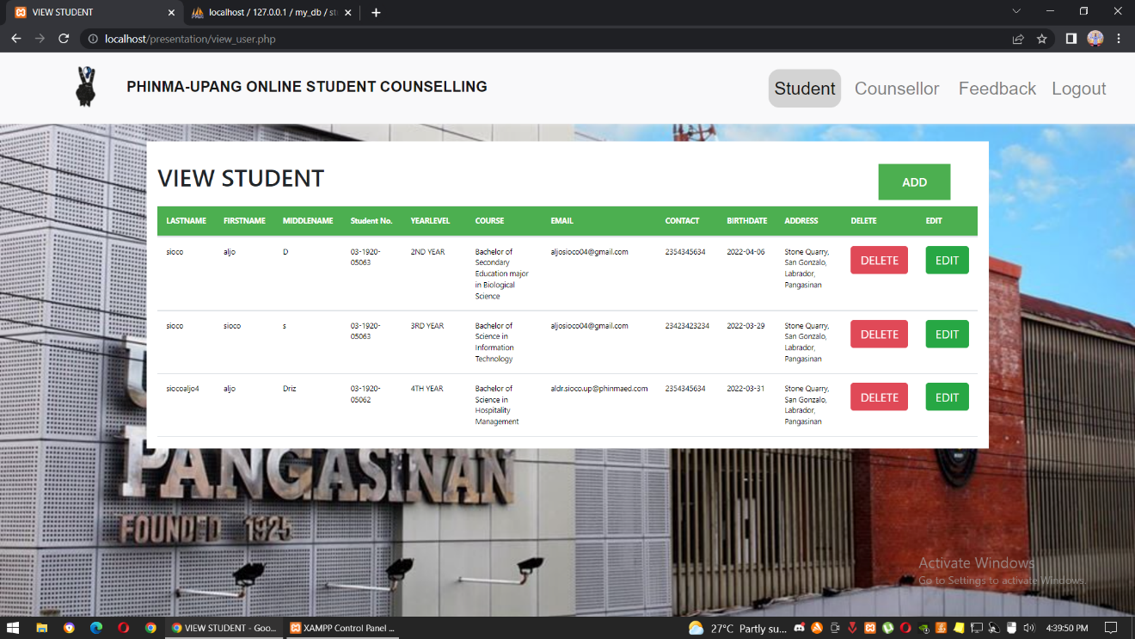

Module 7. Add form – a form where you can add a student. This consist of their full name, student number, year level, course, email address, contact number, birthdate and address.

Figure 19

Add Form

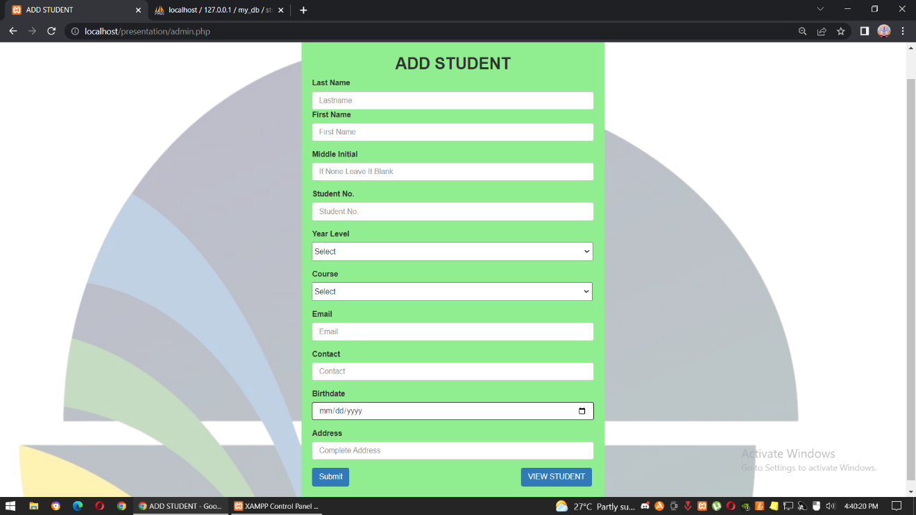

Module 8. Edit – a from where the admin can edit or update the information of the student/s. The content of the form is same in the add student form.

Figure 20

Edit Form

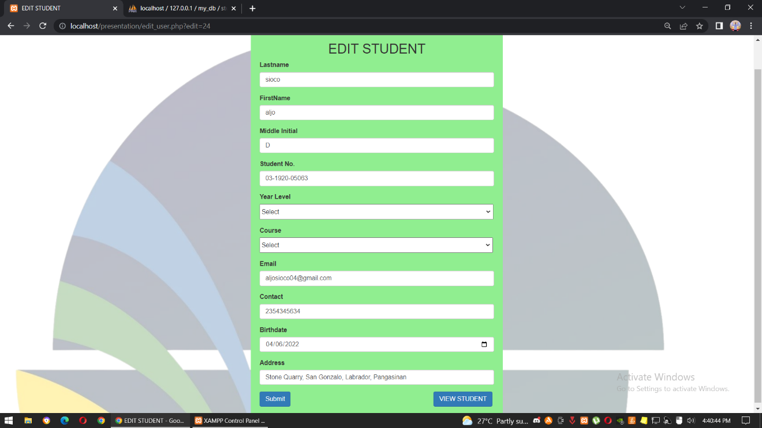

Module 9. Counsellor Login - Where counselors will login their accounts. In the counsellor page, we can see the information of the counsellor. They can add, edit or delete a counsellor account.

Figure 21

Counsellor Login

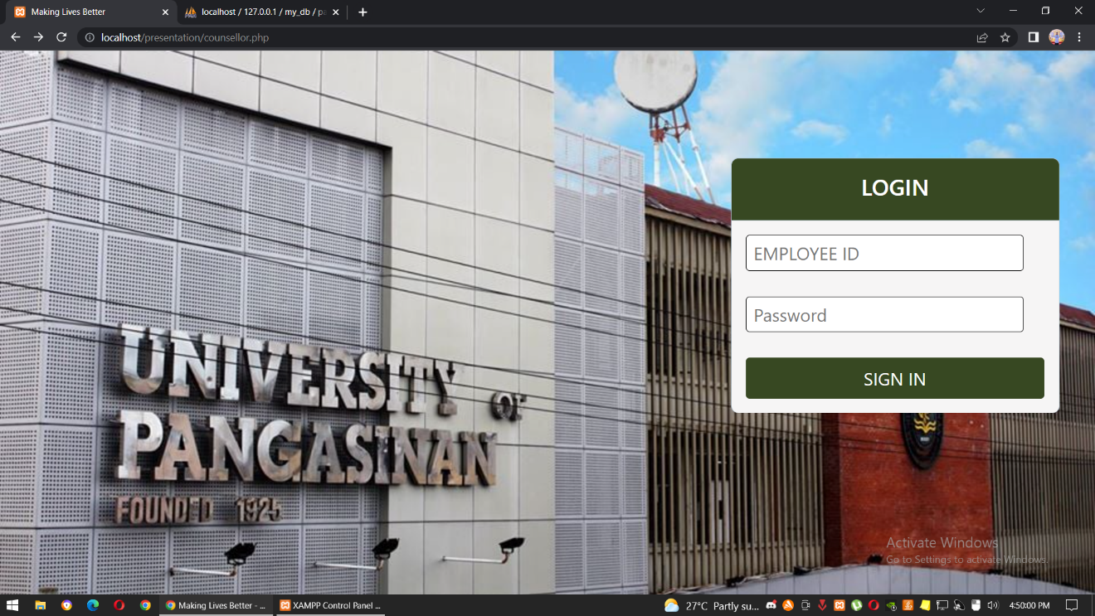

Module 10. View Counsellor - The page where the information of the counsellor can be edited or deleted. Their information includes their full name, employee ID, email address, and their contact number.

Figure 22

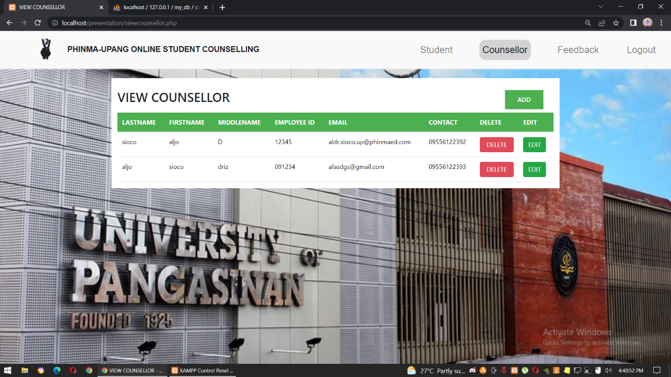View Counsellor

Module 11. Add - form that will add counsellor information. This consist of their full name, employee ID, email address, and their contact number.

Figure 23

Add Form – Counsellor

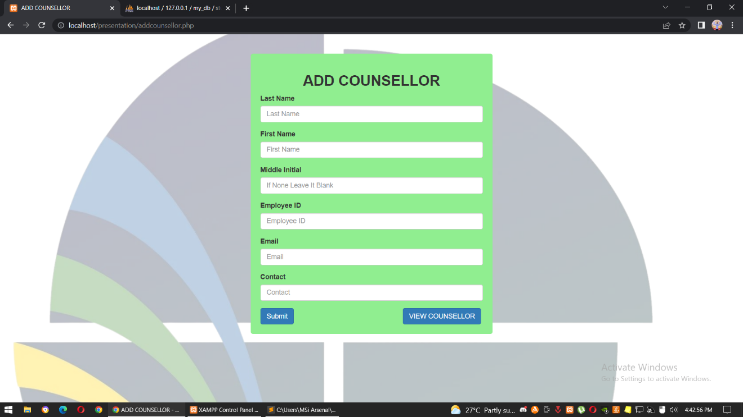

Module 12. Edit – a from that can edit or update the information of the counsellor. The content of the form is same in the add counsellor form.

Figure 24

Edit Modal – Counsellor

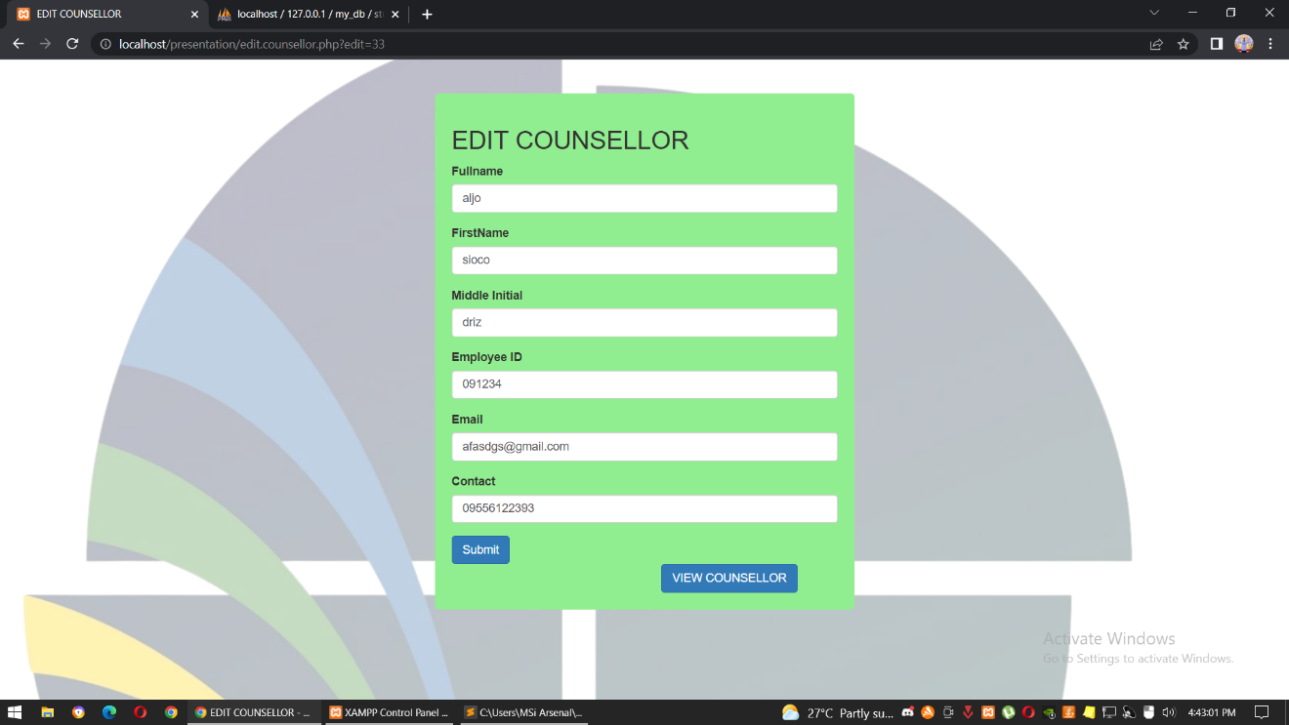

Module 13. Feedback – this page is part of the admin. It will contains the feedback of the user, and if they experience any problem from the system.

Figure 25

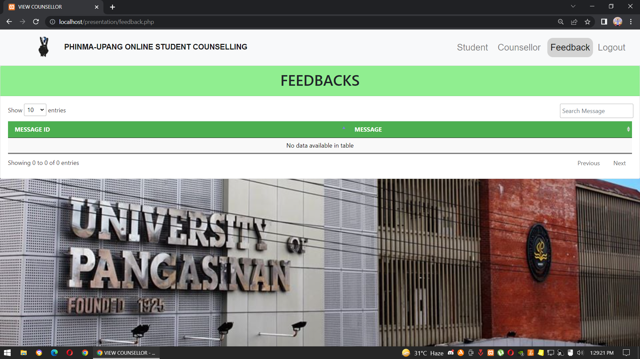Feedback CRUD

Module 14. Appointments – this page will be viewed by the counsellors. This contains the appointments that the students have inserted in the counselling form. It shows their full name, year level, courses, date of the appointment, their issues, and the time of the appointment. When the counsellor approved the appointment, the counsellor will press the approve button and insert the google meet/zoom link in the modal.

Figure 26

Appointments

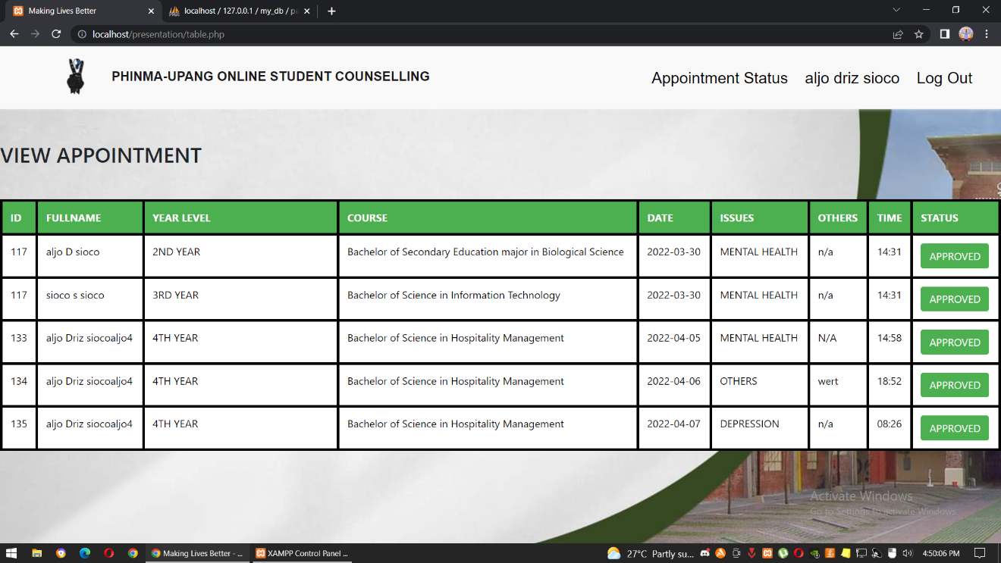

Module 15. History – this history page shows the appointments that the student have made. The history will be only visible to his/her account. It contains the appointment date, their specific issues, the status of their appointment, and the time of the appointment. This page will pop up after they book an appointment.

Figure 27

History

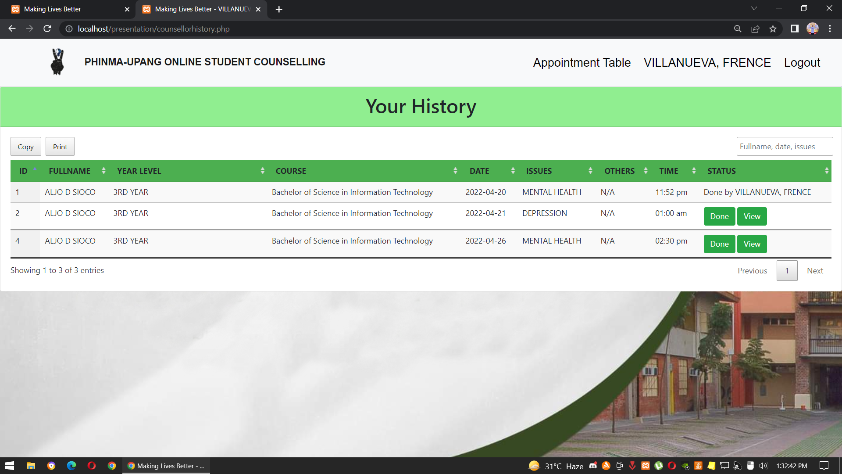

Module 16. Your Appointments – this page will show to the page of the students. It shows the schedules of your appointments, it shows your appointment number, date of your appointment, issues, time of your appointment and your statues.

Figure 28

Your Appointment Page 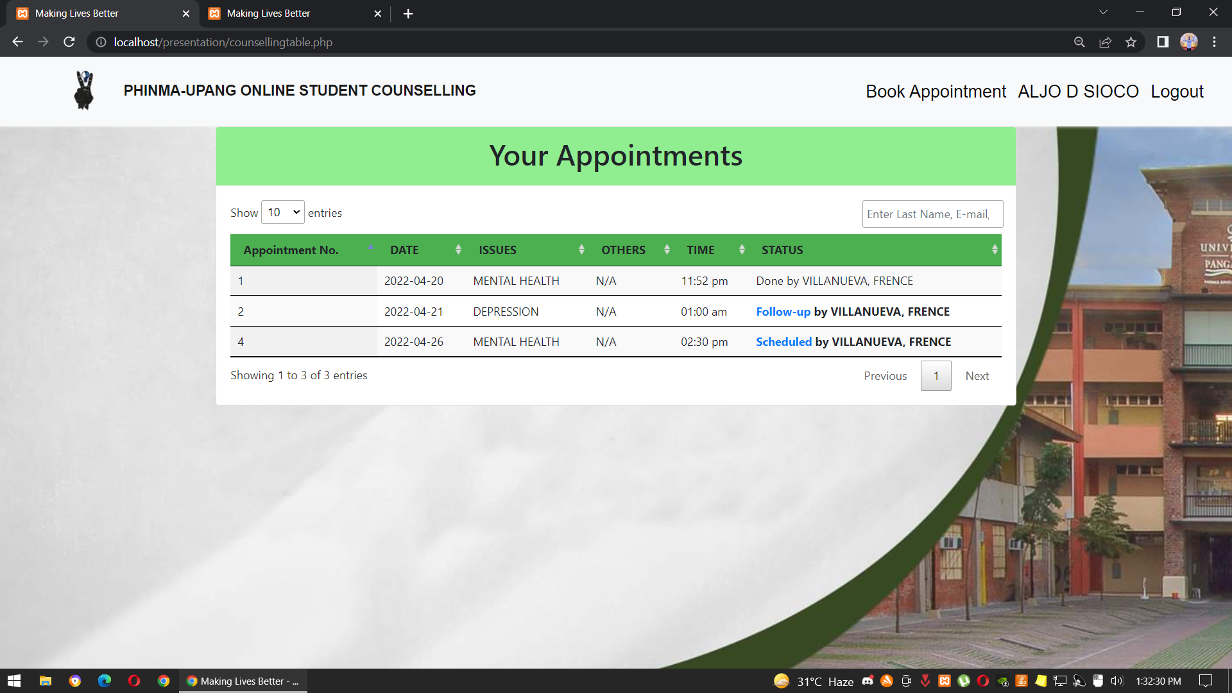

Module 17. Appointment (Counsellor Page) – this page will be viewed by the counsellor. The counsellor will see the appointments of the students. The counsellor will also decide if he/she will approve the student. There is also an copy button or print button if the counsellor will copy or print the information of the student.

Figure 29

Appointment (Counsellor Page) 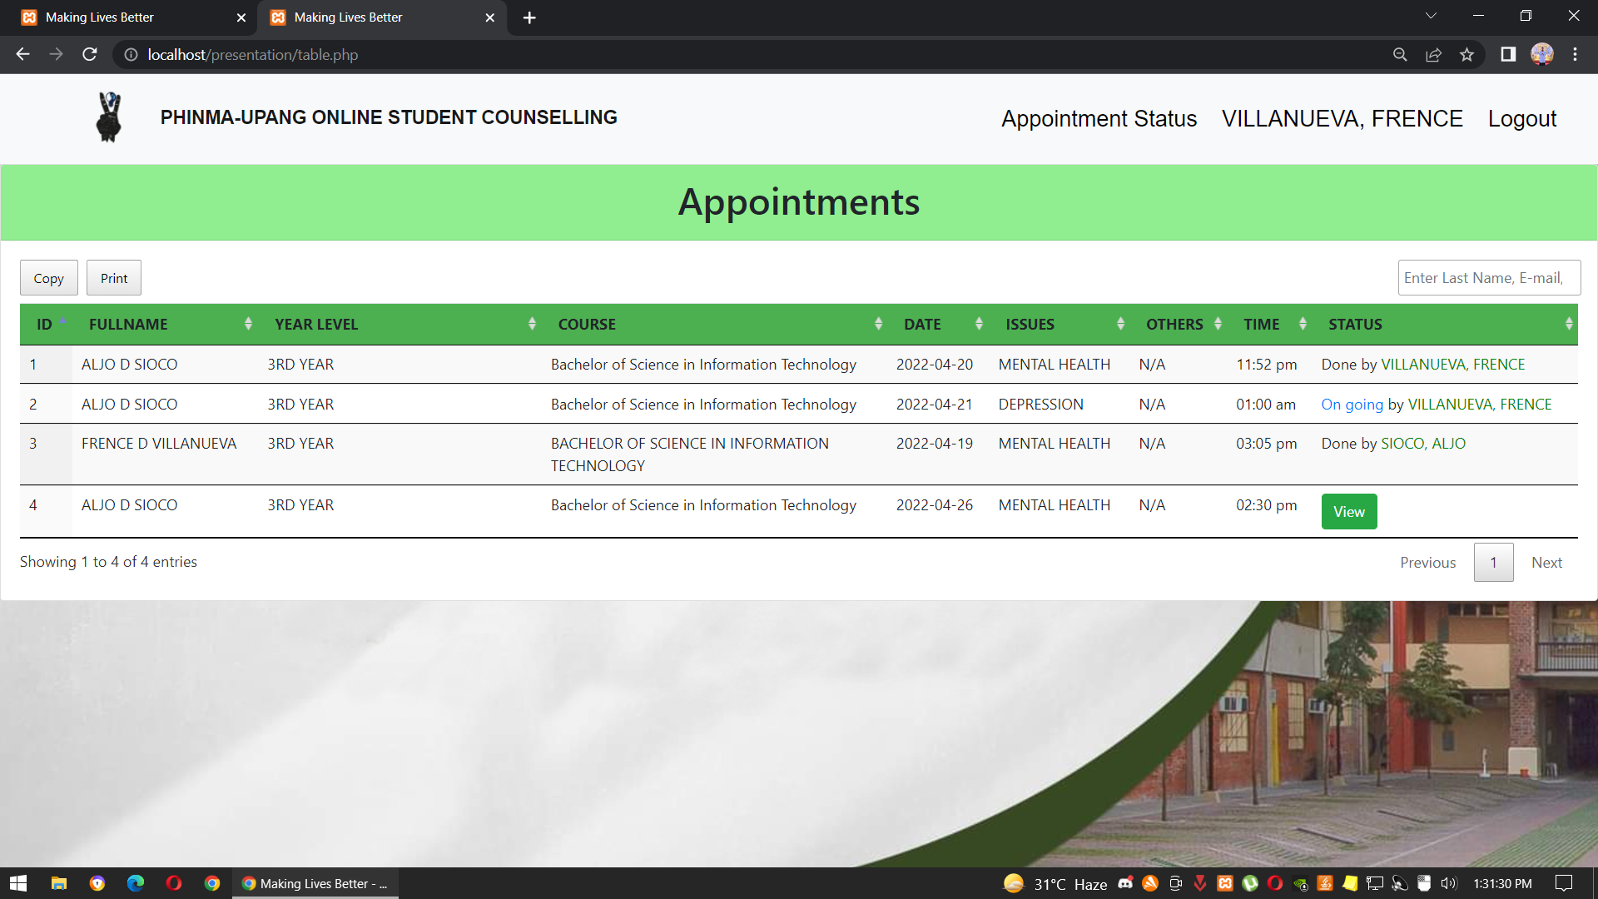

Module 18. Print Module – this page will appear if the counsellor will print the appointment in the counsellor.

Figure 30

Print Module

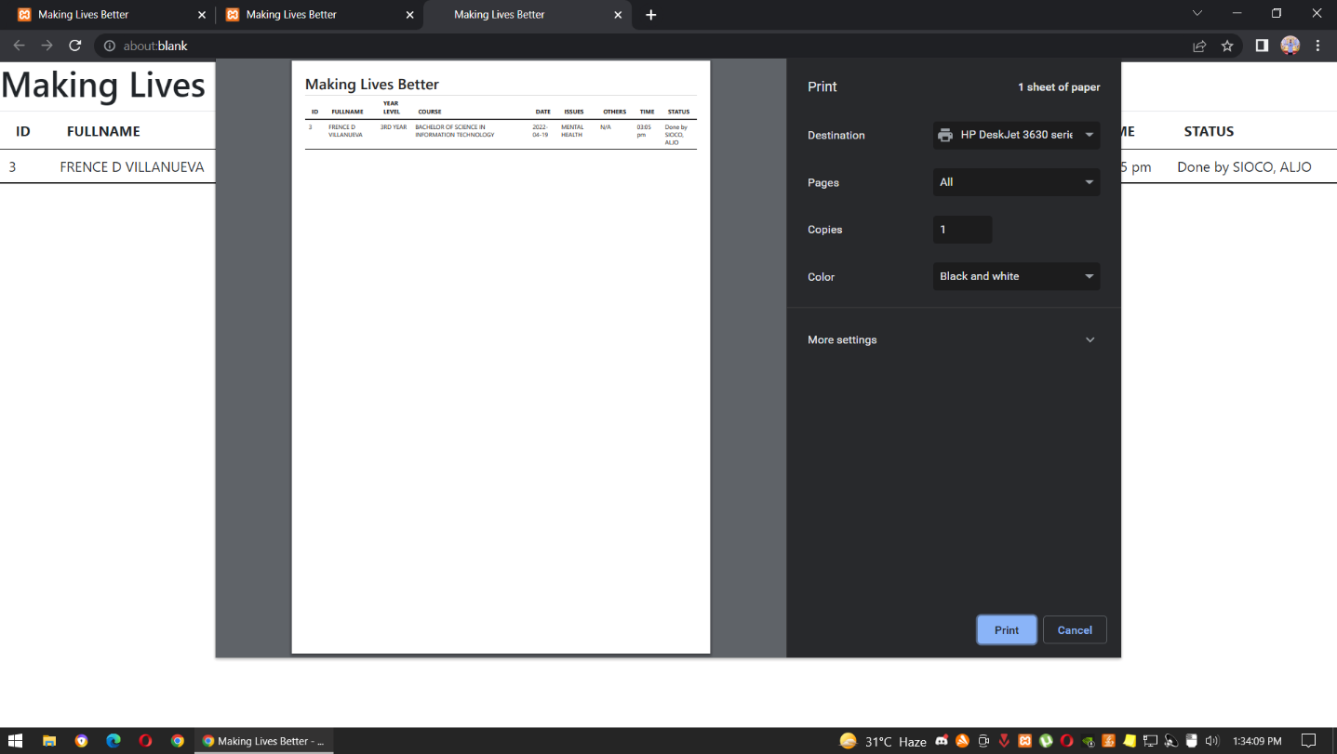

Module 19. Letter – this is the letter that will be sent to the student when the counsellor approved the appointment. The counsellor will insert the google meet or zoom link in the text box. Then the counsellor will press the submit button to send it to the student.

Figure 31

Letter

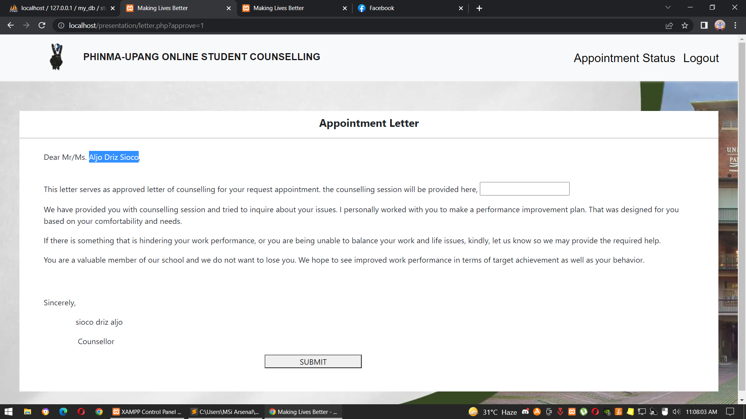

Module 20. Re-counselling – in this form, if the student needs to appoint another counselling for the follow-up meeting with the counsellor, the counsellor will fill-out this form and then the google meet or zoom link will be updated once the form has been fill-out.

Figure 32

Letter

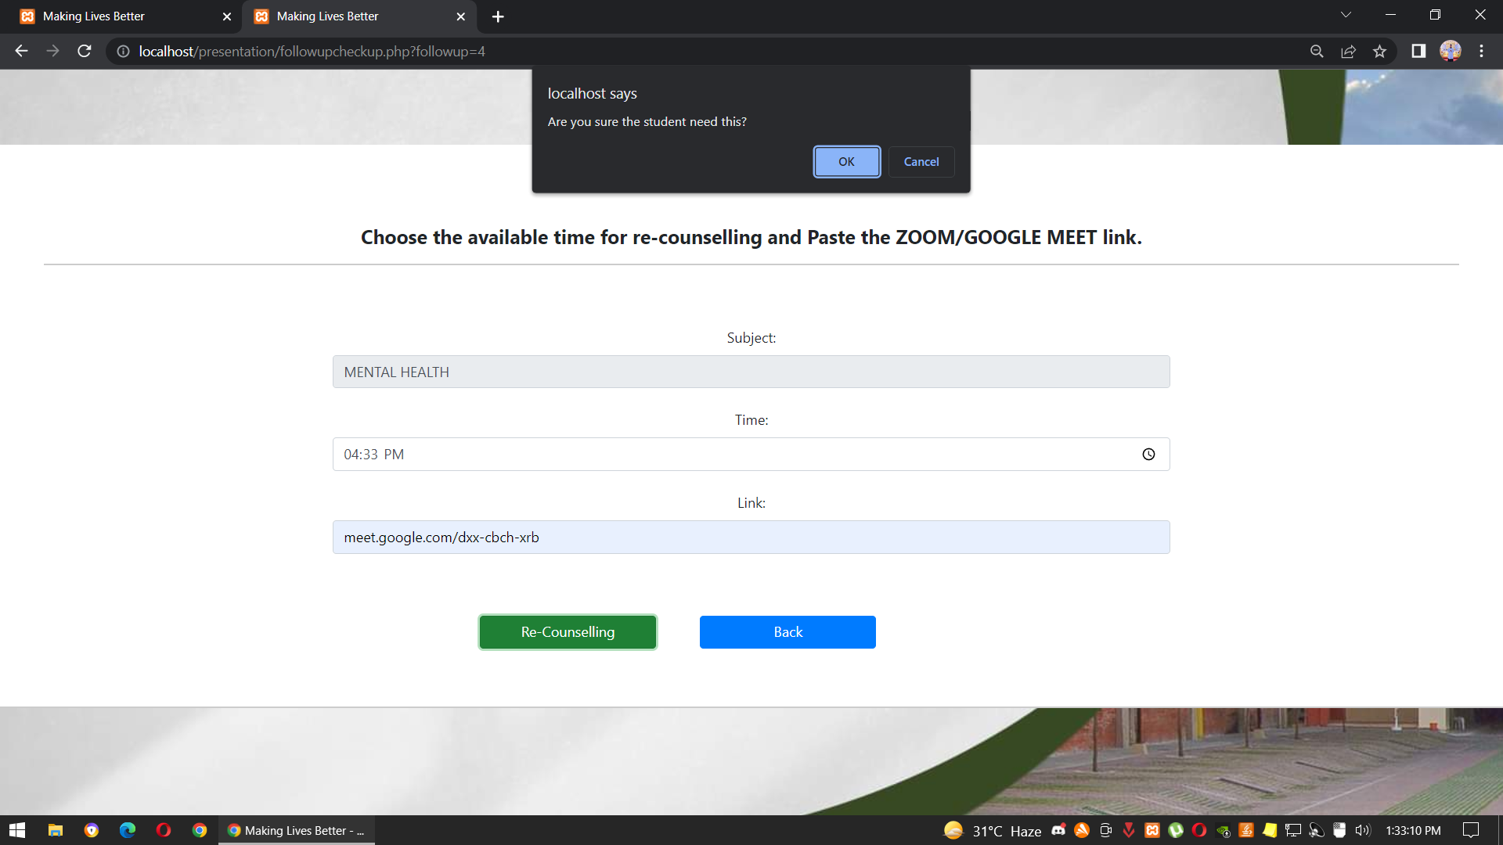

## Interpretation of Data (Software Usability Test)

This section presents the data interpreted based on the results gathered from the participants/respondents. The statistical test results are calculated using the System Usability Scale (SUS), as well as the visual presentation of results is presented in this section.

Figure 33:

SUS Score of SHOPGO Supermarket Delivery System

The average SUS score is 68, higher than 68 SUS score is considered as above average and lower than it is below average. Based on the results that have been collected from the participants of the conducted survey, the average SUS score that we calculated is 68.25%, which means that it is above average. Based on this result, the respondents believe that Online Personal Counselling will be a great help to PHINMA students. We, the Researchers, also believe that this type of system can help more people in PHINMA if it will be a successful program.

The results of this study and its methods are directly dependent on the data collected and its analysis that help in structuring the findings. In order to come up with accurate and timely data needed to produce the right information, the researcher of this study gathered facts from 100 students of PHINMA University of Pangasinan.

## Conclusion

Our project is all about Online Counselling where we set a book of appointments for every students in PHINMA University of Pangasinan who have their personal problems. The objective here is to give some advice to help them solve they're issues.

The said system targets its main purpose as an online counselling that will help the students to improve emotions, behavior and to boost self-confidence. From going to see the doctor for the therapy while pandemic is not lifted, the system provides therapy with the school professor that undergo with Psychology. The assembled features of the system were designed in a best possible way that will make the system convenient for the students. The system also has a history feature that will allow the students view their last appointment.

## Recommendation

Based on the findings and conclusion of the study, here are several recommendations to be considered.

1. Develop a mobile application. So that more students can make appointment while using mobile phones.
2. Make the website accessible to other PHINMA schools.
3. Students can choose who’s counsellor they want or prefer.

**REFERENCES**

1. Published Materials

Jonell Smith Ewan Gillon of School of Health and Life Sciences, Glasgow Caledonian University, Glasgow, UK (04 May 2021), Therapists' experiences of providing online counselling: A qualitative study

According to Arnout et al., 2020; Liebrenz et al., 2020, Online/Cyber Counseling Services in the COVID-19 Outbreak: Are They Really New?

1. Websites

Kah P. Wong, Gregory Bonn, Cai L. Tam, and Chee P. Wong (2018), Preferences for Online and/or Face-to-Face Counseling among University Students in Malaysia

## Appendix A

Survey Questionnaire

**Online Personal Counselling for Students in PHINMA University of Pangasinan**

Counseling is a helping relationship that is different from just talking with a family member or a friend and occurs when a person talks with a trained mental health professional. Counseling helps people to develop the skills to better confront and cope with uncertainties and/or conflicts by creating a non-judgmental and collaborative environment between the counselor and his/her client.

Please read each question carefully as the questions frequently change between face-to-face and online counseling methods. There are no “wrong” answers, and the only “right” answer is the one you honestly feel or believe. Thank you for your participation.

**Name (Optional): Date:**

**Year & Course:** **Age**:

**Instructions: Please check ( ✓) one box for each questions below to show how much you agree and disagree with it.**

|  |  |  |  |  |  |
| --- | --- | --- | --- | --- | --- |
|  | **Fully Agree** | **Agree** | **Neutral** | **Disagree** | **Fully Disagree** |
| Do you believe online mental health counselling or therapy can bd as effective as in-person treatment? |  |  |  |  |  |
| Do you think online health counselling with a therapist you have not met in person can offer effective therapy? |  |  |  |  |  |
| Do you believe that it’s easy to say or discuss your emotional problems with an online counselor? |  |  |  |  |  |
| Do online health counseling helps you to be the best version of yourself? |  |  |  |  |  |
| Online counseling can help me to learn more about myself? |  |  |  |  |  |
| If your friend (Upang Students) had personal problems, you might encourage him or her to join online counselling? |  |  |  |  |  |
| In future, would you use online counselling if you needed mental health services? |  |  |  |  |  |
| Do you believe that seeking help with a online counselor will help students to maintain their mental health? |  |  |  |  |  |

Table 2

**APPENDIX B**

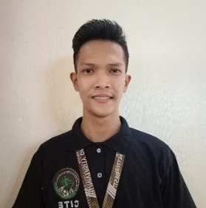**CURRICULUM VITAE**

**Aljo D. Sioco**

Stone Quarry, San Gonzalo, Labrador, Pangasinan

09215001558

[aldr.sioco.up@phinmaed.com](mailto:juan_delacruz@yahoo.com)

**___________________________________________________________**

**PERSONAL INFORMATION**

Birthdate: June 4, 2001

Civil Status: Single

Gender: Male

Religious Affiliation: Roman Catholic

**___________________________________________________________**

**EDUCATIONAL ATTAINMENT**

Tertiary: University of Pangasinan

Dagupan city, Pangasinan

Bachelor of information technology

2019-present

Secondary: St. Columban's School INC

Poblacion, Labrador, Pangasinan

2013-2019

Elementary: Labrador central school

Poblacion, Labrador, Pangasinan

2007-2013

**___________________________________________________________**

**IT SKILLS AND CERTIFICATIONS**

1. Knowledge on Java, Python, HTML, CSS PHP and MySQL.
2. Have experience being software technician in the church activities.



**Dhiven Paul D. Saplan**

89, Nagsaing Calasiao, Pangasinan

09159477863

[dhivensaplan@gmail.com](mailto:juan_delacruz@yahoo.com)

**___________________________________________________________**

**PERSONAL INFORMATION**

Birthdate: February 4, 2001

Civil Status: Single

Gender: Male

Religious Affiliation: Roman Catholic

**___________________________________________________________**

**EDUCATIONAL ATTAINMENT**

Tertiary: University of Pangasinan

Dagupan city, Pangasinan

Bachelor of information technology

2019-present

Secondary: Doyong Malabago National High School

Doyong, Calasiao Pangasinan

2013-1017

PHINMA University of Pangasinan

Dagupan City

2017-2019

Elementary: Nagsaing Elementary School

Nagsaing, Calasiao

2007-2013

**___________________________________________________________**

**IT SKILLS AND CERTIFICATIONS**

1. Oriented in HTML5, CSS, JavaScript, PHP and MySQL
2. Able to adapt with new work environment quickly

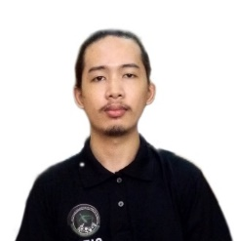

**Cristian AJ C. Delos Reyes**

China St. Bonuan Binloc, Dagupan City, Pangasinan

09239175784

[caj1221312@gmail.com](mailto:juan_delacruz@yahoo.com)

**___________________________________________________________**

**PERSONAL INFORMATION**

Birthdate: June 13, 2001

Civil Status: Single

Gender: Male

Religious Affiliation: Roman Catholic

**___________________________________________________________**

**EDUCATIONAL ATTAINMENT**

Tertiary: University of Pangasinan

Dagupan city, Pangasinan

Bachelor of information technology

2019-present

Secondary: St. John’s Cathedral School

Zamora St. Dagupan City, Pangasinan

2013-2019

Elementary: St. John’s Cathedral School

Zamora St. Dagupan City, Pangasinan

2007-2013

**___________________________________________________________**

**IT SKILLS AND CERTIFICATIONS**

1. Have a knowledge in HTML, PHP, CSS and Python
2. Time management and adaptability.

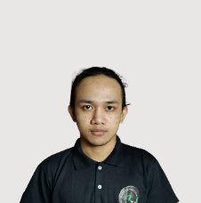

**Frence E. Villanueva**

A.B Fernandez Avenue, Dagupan City, Pangasinan

09305054380

[frencevillanueva@gmail.com](mailto:frencevillanueva@gmail.com)

**___________________________________________________________**

**PERSONAL INFORMATION**

Birthdate: October 11, 2000

Civil Status: Single

Gender: Male

Religious Affiliation: Roman Catholic

**___________________________________________________________**

**EDUCATIONAL ATTAINMENT**

Tertiary: University of Pangasinan

Dagupan city, Pangasinan

Bachelor of information technology

2019-present

Secondary: St. John’s Cathedral School

Zamora St. Dagupan City, Pangasinan

2013-2019

Elementary: West Central Elementary School

Dagupan City, Pangasinan

2007-2013

**___________________________________________________________**

**IT SKILLS AND CERTIFICATIONS**

1. MS Office, Graphics, Adobe Photoshop, HTML and CSS



**Alex Joshua B. Calderon**

459 Pantal West, Dagupan City, Pangasinan

09062429647

[joshcalderon022@gmail.com](mailto:joshcalderon022@gmail.com)

**___________________________________________________________**

**PERSONAL INFORMATION**

Birthdate: April 8, 2001

Civil Status: Single

Gender: Male

Religious Affiliation: Roman Catholic

**___________________________________________________________**

**EDUCATIONAL ATTAINMENT**

Tertiary: University of Pangasinan

Dagupan city, Pangasinan

Bachelor of information technology

2019-present

Secondary: St. John’s Cathedral School

Zamora St. Dagupan City, Pangasinan

2013-2019

Elementary: Pantal Elementary School

Pantal, Dagupan City, Pangasinan

2007-2013

**___________________________________________________________**

**IT SKILLS AND CERTIFICATIONS**

1. Adobe Photoshop, Sublime, HTML